**USDA-NRCS**

GEOSPATIAL TECHNOLOGY APPLICATIONS

**CERTIFIED WETLAND DETERMINATION GEOSPATIAL DATA MODEL AND MAPPING STANDARD**

VERSION 3.1

NRCS USE ONLY

September 30, 2021

Table of Contents

1. Introduction 1

1.1 Background 1

1.2 Objectives 2

1.3 Scope 2

1.4 Applicability 2

2. Data Model 3

2.1 Local Data Model 3

2.1.1 CLU Feature Class 4

2.1.2 Tract Feature Class 8

2.1.3 Define AOI Feature Class and Request Extent Feature Class 9

2.1.4 Sampling Unit Feature Class 11

2.1.5 Representative Observation Point (ROP) Feature Class 15

2.1.6 Reference Points (RP) Feature Class 17

2.1.7 Drainage Lines Feature Class 19

2.1.8 Potential Jurisdictional Waters (PJW) Feature Class 22

2.1.9 Certified Wetland Determination (CWD) Feature Class 23

2.1.10 CLU Certified Wetland Determination (CLU CWD) Feature Class 26

2.2 GIS States GeoPortal Data Model 28

2.2.1 Request Extents HFS 29

2.2.2 All Request Extents HFS 29

2.2.3 Request Extent Points HFS 29

2.2.4 All Request Extent Points HFS 29

2.2.5 Sampling Units HFS 30

2.2.6 All Sampling Units HFS 30

2.2.7 Representative Observation Points (ROPs) HFS 31

2.2.8 All Representative Observation Points (ROPs) HFS 31

2.2.9 Reference Points HFS 32

2.2.10 All Reference Points HFS 32

2.2.11 Drainage Lines HFS 33

2.2.12 All Drainage Lines HFS 33

2.2.13 Certified Wetland Determinations (CWD) HFS 34

2.2.14 All Certified Wetland Determinations HFS 34

2.2.15 Certified Wetland Determinations Points HFS 34

2.2.16 All Certified Wetland Determinations Points HFS 34

2.2.17 CLU Certified Wetland Determinations (CLU CWD) HFS 35

2.2.18 All CLU Certified Wetland Determinations HFS 35

2.2.19 Potential Jurisdictional Waters (PJW) HFS 36

2.2.20 All Potential Jurisdictional Waters (PJW) HFS 36

2.3 Data Model Domains 37

2.3.1 YN Domain 37

2.3.2 Yes-No Domain 37

2.3.3 ROP Status Domain 37

2.3.4 Data Form Domain 37

2.3.5 Line Type Domain 37

2.3.6 Pre-Post Domain 37

2.3.7 Method Domain 37

2.3.8 CWD Status Domain 38

2.3.9 Request Type Domain 38

2.3.10 Evaluation Status Domain 38

2.3.11 Wetland Labels Domain 39

2.4 Source Datasets 40

2.4.1 FSA CLU (from FSA Web Service) 40

2.4.2 NRCS Soil Survey (Soil Data Access) 40

2.4.3 USGS NHD 40

2.4.4 US FWS National Wetland Inventory (NWI) 40

2.4.5 BLM PLSS Query Services 40

2.4.6 Best Available NAIP 40

2.4.7 NRCS Elevation Services 40

2.4.8 Local Datasets 40

2.5 Coordinate Systems 41

2.5.1 GIS States GeoPortal Layers 41

2.5.2 State/Local APRX Template Maps 41

2.5.3 Determination Tool Workflow Datasets 41

2.5.4 Local Reference Datasets 41

2.6 Accuracy 42

2.6.1 Horizontal Accuracy 42

2.6.2 Accuracy Assessment 42

2.7 Topology Rules and Logical Consistency 43

3. References 44

4. Participants 45

1. Introduction

This version is to provide a geospatial data model and mapping standard for supporting a wetland determinations mapping tool used to create wetland determination products and to upload data into a Certified Wetland Determinations hosted feature service for each state, prior to the implementation of these types of workflows in Conservation Desktop. This data model and the referenced tool are not directly linked to the HELC/WC Tracker in Conservation Desktop.

* 1. Background

Eligibility for USDA Program benefits related to the 1985 Food Security Act (Act), as amended, Wetland Conservation (WC) provisions are determined by a cooperative effort between Farm Service Agency (FSA) and the Natural Resources Conservation Service (NRCS). NRCS follows guidance from the National Food Security Act Manual Fifth Edition (NFSAM), which states the following for delineating wetlands:

“The Food Security Act of 1985, as amended, requires NRCS to delineate, determine, and certify wetlands located on land on a farm or ranch subject to wetland conservation (WC) provisions in order to establish a producer’s eligibility for certain USDA program benefits (16 U.S.C. Section 3822, 7 CFR Section 12.30).”

In addition, NFSAM specifies the manner in which NRCS will prepare the certified wetland determination and delineation, as follows:

“NRCS will delineate all wetlands subject to the WC provisions by outlining the boundaries of the wetland on aerial photography, digital imagery, or other graphic representation. If possible, NRCS will use the Global Positioning System (GPS) to digitally map the wetland boundary in the field and to import that data onto digital orthophotoquadrangle maps (DOQ) or other Geographic Information System (GIS) digital photographic imagery. Refer to Part 514, Subparts B through E, to determine the appropriate labels to apply to the delineated wetland types.”

“The complete boundaries and size of all fields that were delineated and identified must be shown on the map, including areas identified as non-wetland (NW). The label and acreage information from the map will be used to prepare the NRCS-CPA-026. A copy of the NRCS-CPA-026, along with the delineation map, will be provided to the USDA program participant and FSA and retained in the participant’s NRCS case file.”

FSA began converting Common Land Unit (CLU) boundaries to digital data in the late 1990’s. The CLU boundaries were captured from existing FSA aerial imagery upon which the CLU tract and field boundaries had been manually delineated. The physical copy of the imagery at the time also contained the official USDA wetland determinations mandated by the Act. During the CLU development process, FSA chose not to capture the wetland boundary determinations, but rather to identify the occurrence of a wetland with a blue dot symbol within a farm field boundary. The use of the blue dots was an interim step to NRCS developing and maintaining a GIS dataset reflecting wetland boundary delineations and designations (NRCS FSA, 2006).

* 1. Objectives

The objective of this data model and standard is to support the implementation of an enterprise-lite version of a wetland determination tool to meet the requirements of the NFSAM for accurate delineation and identification of wetlands for compliance with the WC provisions of the Act. The elements of this standard have been developed to facilitate and ensure certified wetland determinations are completed, retrievable, and recorded consistently.

* 1. Scope

This data model and standard will apply to the Certified Wetland Determination dataset, and related datasets, to represent the location and identification of areas that have been mapped and considered to have a certified wetland determination defined by the Act in the United States and Territories subject to the Act.

* 1. Applicability

This data model and mapping standard is for use by NRCS to develop an interim wetland determination tool and related geospatial datasets that will create products for issuing, and retaining records of, a wetland determination. This data model and mapping standard will eventually be replaced by tools, workflows, and datasets integrated into the Conservation Desktop application.

1. Data Model

The geospatial data model is built around two components, a local component and an online component using the NRCS GeoPortal. The local component is built around feature classes and tabular data. The GeoPortal component is built around hosted feature layers, web maps, and operations dashboards. The model is designed to capture the complex requirements for the determination data and workflow. Implementation of this data model and mapping standard will enhance effective customer service, response times, and conservation delivery implementation.

* 1. Local Data Model

Local feature classes are maintained as templates in a source geodatabase in the tool installation folder. They are then called and processed on a per project basis by the wetland determination tool and its workflow. Project files are managed on a per site basis and feature class creation, updates, and topology are maintained by validation rules and functions built into the wetland determination tool workflow. These data are used to define the project site and request extent, the sampling units, and the determination delineations for each project. Local Data from each project is passed into the GeoPortal data model and its hosted feature layers.

* + 1. CLU Feature Class

The CLU Feature Class is a polygon feature class consisting of a copy of all fields from a single tract of the FSA CLU layer. Field data is used to provide administrative data to the current project and field extents are used to promote alignment of data within the current project.

* + - 1. Workflow Components and Relationships

The CLU Feature Class is created by downloading all fields of a specified CLU Tract from the FSA CLU web service and storing them in a local file geodatabase for the current project. This feature class is then used to select CLU fields which contain areas to be determined, to create a tract boundary layer, and as part of creating the current project’s Certified Wetland Determination Feature Class. This feature class is also used for cartographic purposes during the workflow. This feature class is added to the current project’s map as a layer.

* + - 1. Attributes

Attributes are inherited from the downloaded FSA CLU layer. FSA CLU attributes not listed here are dropped from this feature class upon its creation.

1. *Name*: GlobalID (Required)

*Alias*: GlobalID

*Data Type*: Global ID

*Value Description*: System Generated. Unique ID per feature.

*Default Value*: System generated

1. *Name*: job_id (Required)

*Alias*: Job ID

*Data Type*: String/Text

*Length*: 128

*Value Description*: Tool Generated. All features for the current request receive a matching Job ID that is used at the end of the process to help sync data with the online data services.

*Default Value*: Tool generated

1. *Name*: admin_state (Required)

*Alias*: admin_state

*Data Type*: String/Text

*Length*: 2

*Value Description*: 2-character FIPS code representing the administrative state or territory of each CLU field

*Default Value*: Inherited from import

1. *Name*: admin_state_name (Required)

*Alias*: Admin State Name

*Data Type*: String/Text

*Length*: 64

*Value Description*: Administrative state name

*Default Value*: Computed from lookup table

1. *Name*: admin_county (Required)

*Alias*: admin_county

*Data Type*: String/Text

*Length*: 3

*Value Description*: 3-character FIPS code representing the administrative county or parish of each CLU field

*Default Value*: Inherited from import

1. *Name*: admin_county_name (Required)

*Alias*: Admin County Name

*Data Type*: String/Text

*Length*: 64

*Value Description*: Administrative county name

*Default Value*: Computed from lookup table

1. *Name*: state_code (Required)

*Alias*: state_code

*Data Type*: String/Text

*Length*: 2

*Value Description*: 2-character FIPS code representing the geographic state or territory of each CLU field

*Default Value*: Inherited from import

1. *Name*: state_name (Required)

*Alias*: State Name

*Data Type*: String/Text

*Length*: 64

*Value Description*: Geographic state name

*Default Value*: Computed from lookup table

1. *Name*: county_code (Required)

*Alias*: County Code

*Data Type*: String/Text

*Length*: 3

*Value Description*: 3-character FIPS code representing the geographic county or parish of each CLU field

*Default Value*: Inherited from import

1. *Name*: county_name (Required)

*Alias*: County Name

*Data Type*: String/Text

*Length*: 64

*Value Description*: Geographic county name

*Default Value*: Computed from lookup table

1. *Name*: farm_number (Required)

*Alias*: Farm Number

*Data Type*: String/Text

*Length*: 7

*Value Description*: A 1- to 7-digit farm number for each CLU field

*Default Value*: Inherited from import

1. *Name*: tract_number (Required)

*Alias*: Tract Number

*Data Type*: String/Text

*Length*: 7

*Value Description*: A 1- to 7-digit tract number for each CLU field

*Default Value*: Inherited from import

1. *Name*: clu_number (Required)

*Alias*: CLU Number

*Data Type*: String/Text

*Length*: 7

*Value Description*: A 1- to 7-digit field number for each CLU field

*Default Value*: Inherited from import

1. *Name*: clu_calculated_acreage (Required)

*Alias*: CLU Calculated Acreage

*Data Type*: Double

*Value Description*: The acres for each CLU field as calculated by FSA. FSA calculates by multiplying square meters in NAD83 UTM for the field location by 0.0002471. This conversion factor causes a slight discrepancy from actual acres (should use 0.000247105).

*Default Value*: Inherited from import

1. *Name*: highly_erodible_land_type_code (Optional)

*Alias*: Highly Erodible Land Type Code

*Data Type*: String/Text

*Length*: 4

*Value Description*: The HEL determination attribute for the field stored by FSA: UHEL, NHEL, or HEL. This attribute is only used for reference information in the wetland determination workflow.

*Default Value*: Inherited from import

1. *Name*: creation_date (Optional)

*Alias*: Creation Date

*Data Type*: Date

*Value Description*: FSA tracking attribute from its database for the date that the field record was created.

*Default Value*: Inherited from import

1. *Name*: last_change_date (Optional)

*Alias*: Last Change Date

*Data Type*: Date

*Value Description*: FSA tracking attribute from its database for the date that the field record was last modified.

*Default Value*: Inherited from import

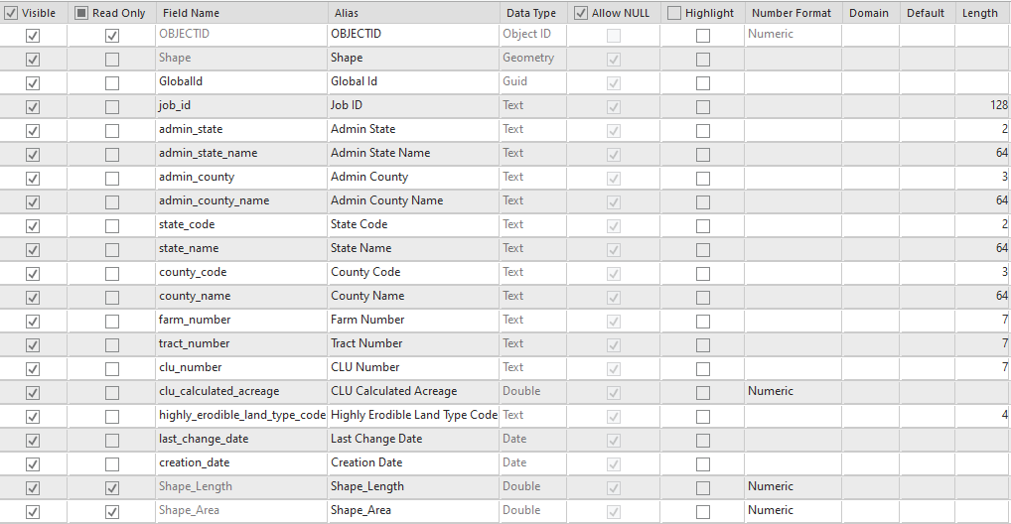

Figure 1 - CLU Feature Class Attribute Fields

* + 1. Tract Feature Class

The Tract Feature Class is a polygon feature class that consists of the outer extent of all CLU fields for the specified tract. It is used to control the maximum editing extent for the current determination project.

* + - 1. Workflow Components and Relationships

The Tract Feature Class is created by dissolving together the CLU Feature Class by Admin State, Admin State Name, Admin County, Admin County Name, State Code, State Name, County Code, County Name, Farm Number, and Tract Number and gets stored in the local project’s file geodatabase. It is used as a starting point to buffer an extent for use in generating supplemental reference datasets to display with the current determination project. This feature class is not added to the current project’s map as a layer.

* + - 1. Attributes

Attributes are inherited from the downloaded FSA CLU layer through the dissolve process. FSA CLU attributes at the tract level are retained, and attributes at the CLU Number (or field) level are dropped. This results in omitting CLU Number, CLU Calculated Acreage, Highly Erodible Land Type Code, Creation Date, and Last Change Date from this layer.

* + 1. Define AOI Feature Class and Request Extent Feature Class

The Define AOI Feature Class is a polygon feature class that is used to define the maximum extent of the requested area for determination for the current site or project. It can be multipart. The Request Extent Feature Class is the subsequent output

* + - 1. Workflow Components and Relationships

The Define AOI Feature Class is a copy of the CLU Feature Class and is intended for users to select requested fields or edit into subfields for selection, if necessary. The Request Extent is the output extent from users defining the AOI in the workflow. After this step, the Request Extent is used in the workflow to enforce the maximum determination extent for the site.

* + - 1. Attributes

The Define AOI Feature Class attributes match those of the CLU Feature Class. The Request Extent Attributes match those of the Tract Feature class (field level attributes from the CLU are dropped). The Request Extent Feature Class also has the following unique attribute added.

1. *Name*: GlobalID (Required)

*Alias*: GlobalID

*Data Type*: Global ID

*Value Description*: Unique ID per feature.

*Default Value*: System generated

1. *Name*: eval_status

*Alias*: Evaluation Status

*Data Type*: String/Text

*Length*: 24

*Domain*: Evaluation Status

*Value Description*: The workflow type or status of the requested area.

*Default Value*: New Request (or others depending on workflow)

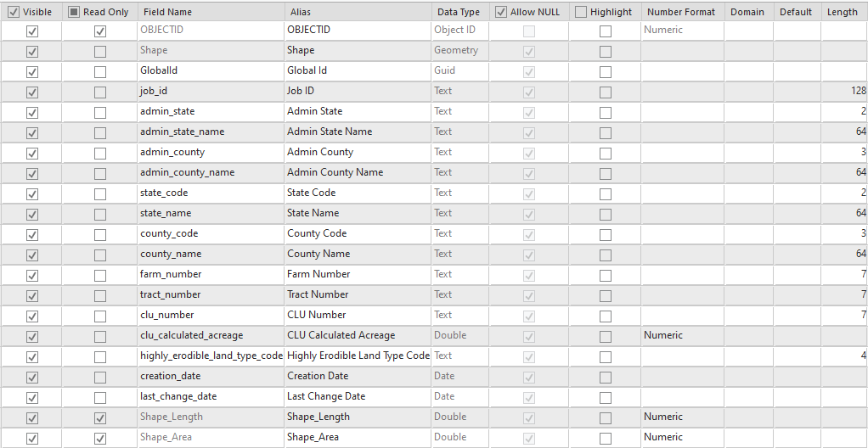

Figure 2 - Define AOI Feature Class Attribute Fields

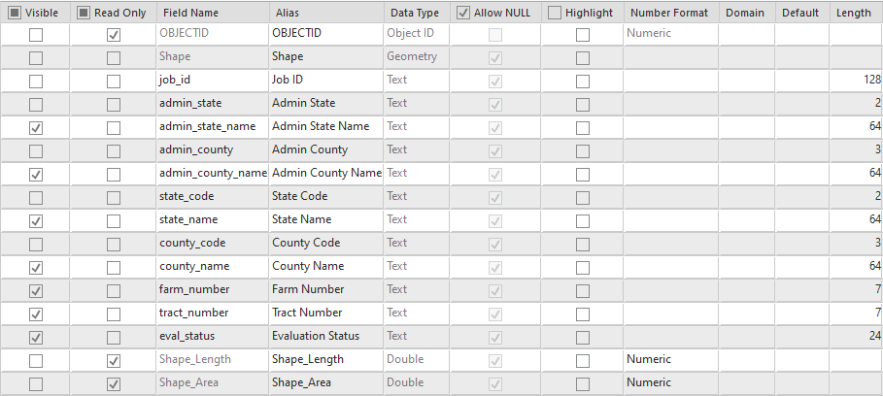

Figure 3 - Request Extent Feature Class Attribute Fields

* + 1. Sampling Unit Feature Class

The Sampling Unit Feature Class is a polygon feature class that is used to define the extent and its sampling units.

* + - 1. Workflow Components and Relationships

The Sampling Unit Feature Class is created by clipping the CLU by the Request Extent. This feature class is edited by users to delineate sampling units (using split, merge, or create). This feature class is also integrated with any previous determination sampling unit extents. This feature class is added to map as a layer.

* + - 1. Attributes

Many attributes are inherited from the CLU and others are populated automatically or through user edits. The following attributes are created or calculated uniquely to this class or updated during the editing workflow.

1. *Name*: GlobalID (Required)

*Alias*: GlobalID

*Data Type*: Global ID

*Value Description*: Unique ID per feature.

*Default Value*: System generated

1. *Name*: eval_status

*Alias*: Evaluation Status

*Data Type*: String/Text

*Length*: 24

*Domain*: Evaluation Status

*Value Description*: The workflow type or status of the current sampling unit.

*Default Value*: New Request (or others depending on workflow)

1. *Name*: su_number (Required)

*Alias*: Sampling Unit Number

*Data Type*: Long Integer

*Value Description*: A number assigned by the user to uniquely identify each sampling unit.

*Default Value*: Null

1. *Name*: su_letter (Optional)

*Alias*: Sampling Unit Letter

*Data Type*: String/Text

*Length*: 3

*Value Description*: A letter assigned by the user to uniquely identify sub parts of the same sampling unit number.

*Default Value*: Null

1. *Name*: acres (Required)

*Alias*: Acres

*Data Type*: Double

*Value Description*: Acres calculated by ArcGIS.

*Attribute Rule*: Calculate upon feature insert or update.

*Default Value*: Calculated by GIS on layer creation/updates.

1. *Name*: associated_rop (Required)

*Alias*: Associated ROP

*Data Type*: Long Integer

*Value Description*: The ROP Number of an associated ROP.

*Default Value*: Null

1. *Name*: associated_ref (Optional)

*Alias*: Associated Reference Point

*Data Type*: Long Integer

*Value Description*: The Reference Point Number of an associated Reference Point

*Default Value*: Null

1. *Name*: three_factors (Required)

*Alias*: 3-Factors

*Data Type*: String/Text

*Length*: 3

*Domain*: YN

*Value Description*: Y or N. Set to Y or N based on findings while delineating for whether the three factors for wetlands are confirmed.

*Default Value*: Null

1. *Name*: request_date (Required)

*Alias*: Request Date

*Data Type*: Date

*Value Description*: The date of the request that prompted the determination.

*Default Value*: Assigned from required user parameters

1. *Name*: request_type (Required)

*Alias*: Request Type

*Data Type*: String/Text

*Length*: 12

*Value Description*: The type of request that prompted the determination.

*Default Value*: Assigned from required user parameters

1. *Name*: deter_method (Required)

*Alias*: Determination Method

*Data Type*: String/Text

*Length*: 24

*Value Description*: Selected by the user after creating the feature.

*Domain*: Method

*Default*: Null

1. *Name*: deter_staff (Required)

*Alias*: Determination Staff

*Data Type*: String/Text

*Length*: 100

*Value Description*: The name of the person who is doing or did the determination delineations.

*Default Value*: Current user

1. *Name*: dig_staff (Required)

*Alias*: Digitizing Staff

*Data Type*: String/Text

*Length*: 50

*Value Description*: The name of the person who is digitizing the determination.

*Default Value*: Current user

1. *Name*: dig_date (Required)

*Alias*: Digitizing Date

*Data Type*: Date

*Value Description*: The date of the last edit to the feature.

*Default Value*: Current date or date of last edit/validate

1. *Name*: su_comments (Optional)

*Alias*: Comments

*Date Type*: String/Text

*Length*: 255

*Value Description*: Used to record any other comments, as needed.

*Default Value*: Null

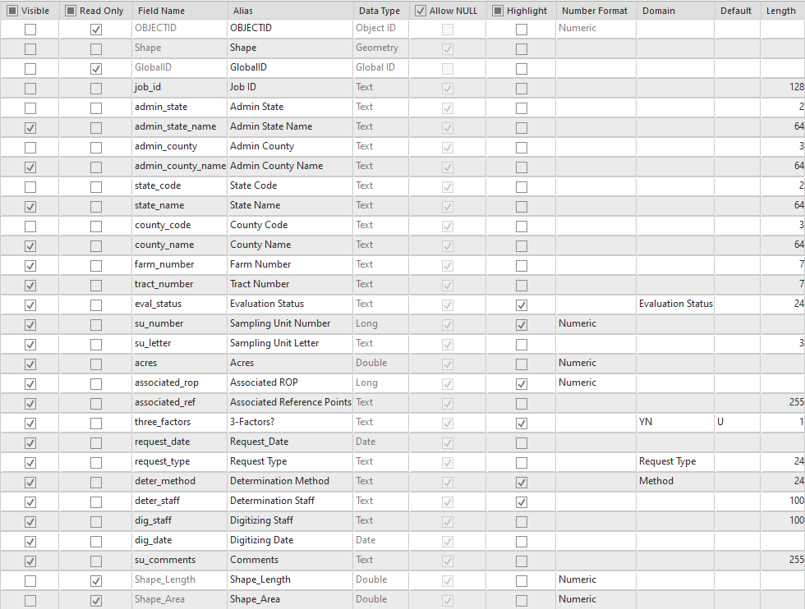

Figure 4 - Sampling Unit Feature Class Attribute Fields

* + 1. Representative Observation Point (ROP) Feature Class

The ROP Feature Class is a point feature class that is used to mark locations of representative observations for a wetland determination.

* + - 1. Workflow Components and Relationships

The ROP Feature Class is an empty template feature class. Features are created and attributed by delineators. Additional attributes are computed during validation. This feature class is added to the map as a layer.

* + - 1. Attributes

Attributes are inherited from the workflow, entered by users, or calculated by validation steps. The following attributes are created or calculated uniquely to this class or updated during the editing workflow:

1. *Name*: GlobalID (Required)

*Alias*: GlobalID

*Data Type*: Global ID

*Value Description*: Unique ID per feature.

*Default Value*: System generated

1. *Name*: rop_number (Required)

*Alias*: ROP Number

*Data Type*: Long Integer

*Value Description*: A number assigned by the user to uniquely identify each ROP point. This number does not have to match the Sampling Unit Number

*Default Value*: Null

1. *Name*: associated_su (Required)

*Alias*: Associated Sampling Units

*Data Type*: String/Text

*Length*: 255

*Value Description*: A comma delimited list of sampling unit numbers for associated sampling units that is populated during data validation.

*Default Value*: Calculated by validation.

1. *Name*: rop_comments (Optional)

*Alias*: Comments

*Date Type*: String/Text

*Length*: 255

*Value Description*: Used to record any other comments, as needed.

*Default Value*: Null

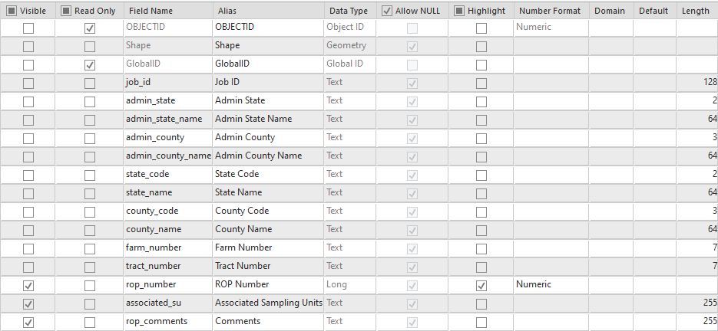

Figure 5 - ROP Feature Class Attribute Fields

* + 1. Reference Points (RP) Feature Class

The Reference Points Feature Class is a point feature class that is used to mark locations of reference points for a wetland determination.

* + - 1. Workflow Components and Relationships

The Reference Points Feature Class is an empty template feature class. Features are created and attributed by delineators. This feature class is added to the map as a layer.

* + - 1. Attributes

Attributes are inherited from the workflow, entered by users, or calculated by validation steps. The following attributes are created or calculated uniquely to this class or updated during the editing workflow:

1. *Name*: GlobalID (Required)

*Alias*: GlobalID

*Data Type*: Global ID

*Value Description*: Unique ID per feature.

*Default Value*: System generated

1. *Name*: ref_number (Required)

*Alias*: Reference Point Number

*Data Type*: Long Integer

*Value Description*: A number assigned by the user to uniquely identify each Reference Point. This number does not have to match the Sampling Unit Number or the ROP Number.

*Default Value*: Null

1. *Name*: parent_rop (Required)

*Alias*: Parent ROP

*Data Type*: Long Integer

*Value Description*: The ROP which the Reference Point supports.

1. *Name*: hydro (Optional)

*Alias*: Documents Hydrology?

*Date Type*: String/Text

*Length*: 3

*Value Description*: Used to indicate if the point references hydrology.

*Domain*: Yes No

*Default Value*: N/A

1. *Name*: veg (Optional)

*Alias*: Documents Vegetation?

*Date Type*: String/Text

*Length*: 3

*Value Description*: Used to indicate if the point references vegetation.

*Domain*: Yes No

*Default Value*: N/A

1. *Name*: soil (Optional)

*Alias*: Documents Soil?

*Date Type*: String/Text

*Length*: 3

*Value Description*: Used to indicate if the point references soil.

*Domain*: Yes No

*Default Value*: N/A

1. *Name*: ref_comments (Optional)

*Alias*: Comments

*Date Type*: String/Text

*Length*: 255

*Value Description*: Used to record any other comments, as needed.

*Default Value*: Null

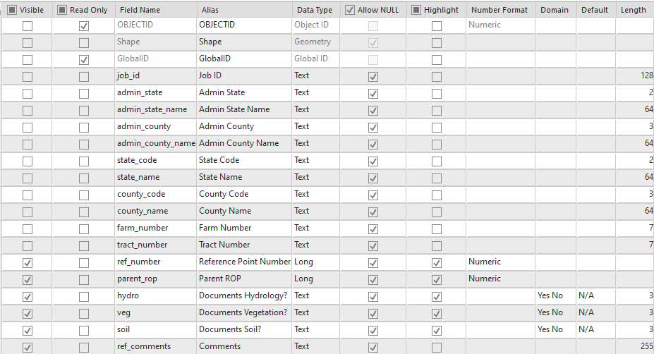

Figure 6 - Reference Points Feature Class Attribute Fields

* + 1. Drainage Lines Feature Class

The Drainage Lines Feature Class is a line feature class that is used to digitized linear features relating to drainage that are relevant to wetland determinations.

* + - 1. Workflow Components and Relationships

The Drainage Lines Feature Class is an empty template feature class. Features are created and attributed by delineators. This feature class is added to the map as a layer.

* + - 1. Attributes

Attributes are inherited from the workflow, entered by users, or from the editing templates. The following attributes are created or calculated uniquely to this class or updated during the editing workflow.

1. *Name*: GlobalID (Required)

*Alias*: GlobalID

*Data Type*: Global ID

*Value Description*: Unique ID per feature.

*Default Value*: System generated

1. *Name*: line_type (Required)

*Alias*: Line Type

*Data Type*: String/Text

*Length*: 50

*Domain*: Line Type

*Value Description*: Type of drainage line.

1. *Name*: manip_era (Required)

*Alias*: Era

*Data Type*: String/Text

*Length*: 12

*Domain*: Pre-Post

*Value Description*: Lists whether the drainage line is from before or after 12/23/1985.

*Default Value*: Linked to the feature’s designed symbology.

1. *Name*: manip_year (Optional)

*Alias*: Manipulation Year

*Date Type*: String/Text

*Length*: 4

*Value Description*: Used to enter a specific year, if needed.

*Default Value*: Null

1. *Name*: line_length (Required)

*Alias*: Length (ft)

*Data Type*: Double

*Value Description*: GIS calculated length in feet.

*Attribute Rule*: Calculate upon feature insert or update.

*Default Value*: Calculated by GIS on layer creation/updates.

1. *Name*: depth (Optional)

*Alias*: Depth (ft)

*Data Type*: Double

*Value Description*: User entered depth in feet.

*Default Value*: Null

1. *Name*: width (Optional)

*Alias*: Width (ft)

*Data Type*: Double

*Value Description*: User entered width in feet.

*Default Value*: Null

1. *Name*: drain_comments (Optional)

*Alias*: Comments

*Date Type*: String/Text

*Length*: 255

*Value Description*: Used to record any other comments, as needed.

*Default Value*: Null

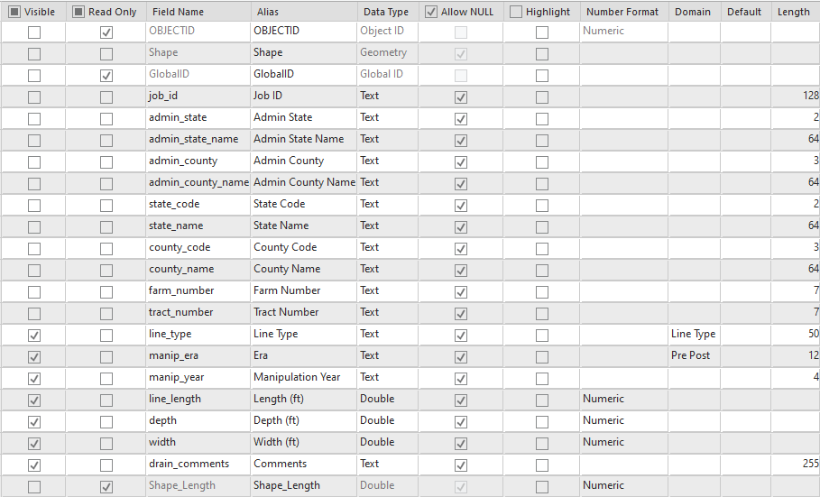

Figure 7 - Drainage Lines Feature Class Attribute Fields

* + 1. Potential Jurisdictional Waters (PJW) Feature Class

The Potential Jurisdictional Waters Feature Class is a point feature class that is used to mark locations that *may* be considered jurisdictional for the Clean Water Act.

* + - 1. Workflow Components and Relationships

The Potential Jurisdictional Waters Feature Class is an empty template feature class. Features are created by delineators. This feature class is added to the map as a layer.

* + - 1. Attributes

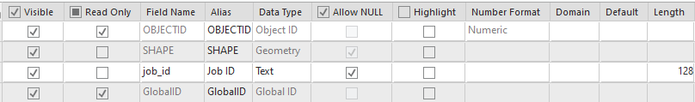There are no attributes for the Potential Jurisdictional Waters Feature Class other than the standard column GlobalID and the inherited Job ID from the project. The feature class is a simple point feature class with a single symbol.

Figure 8 - Potential Jurisdictional Waters Feature Class Attribute Fields

* + 1. Certified Wetland Determination (CWD) Feature Class

The CWD Feature Class is a polygon feature class that is used to delineate extents for wetland determinations and labels.

* + - 1. Workflow Components and Relationships

The CWD Feature Class is created by clipping the Sampling Units feature class by the Request Extent Feature Class and adding the appropriate CWD attributes columns. Additional edits are performed by delineators. This feature class is added to the map as a layer.

* + - 1. Attributes

Attributes are inherited from the CLU Feature Class and the Sampling Unit Feature Class. Sampling Unit designations and associated ROPs or Reference Points are dropped, and the Wetland Label, Occurrence Year, and Certification Date columns are added. The following attributes are created or calculated uniquely to this class or updated during the editing workflow layer:

1. *Name*: GlobalID

*Alias*: GlobalID

*Data Type*: Global ID

*Value Description*: Unique ID per feature.

*Default Value*: System Generated

1. *Name*: wetland_label (Required)

*Alias*: Wetland Label

*Data Type*: String/Text

*Length*: 12

*Domain*: Wetland Labels

*Value Description*: The official determination’s label for a delineation.

*Default Value*: Null

1. *Name*: occur_year (Optional)

*Alias*: Occurrence Year

*Data Type*: String

*Length*: 4

*Value Description*: The year associated to any wetland label ending in “+”. The date will be constrained to a 4-digit year by validation checks.

*Default Value*: Null

1. *Name*: acres (Required)

*Alias*: Acres

*Data Type*: Double

*Value Description*: Acres calculated by ArcGIS.

*Attribute Rule*: Calculate upon feature insert or update.

*Default Value*: Calculated by GIS on layer creation/updates.

1. *Name*: comments (Optional)

*Alias*: Comments

*Date Type*: String/Text

*Length*: 255

*Value Description*: Used to record any other comments, as needed.

*Default Value*: Null

1. *Name*: cert_date (Optional)

*Alias*: Certification Date

*Date Type*: Date

*Value Description*: Legacy value from previous versions of the dataset.

*Default Value*: Null

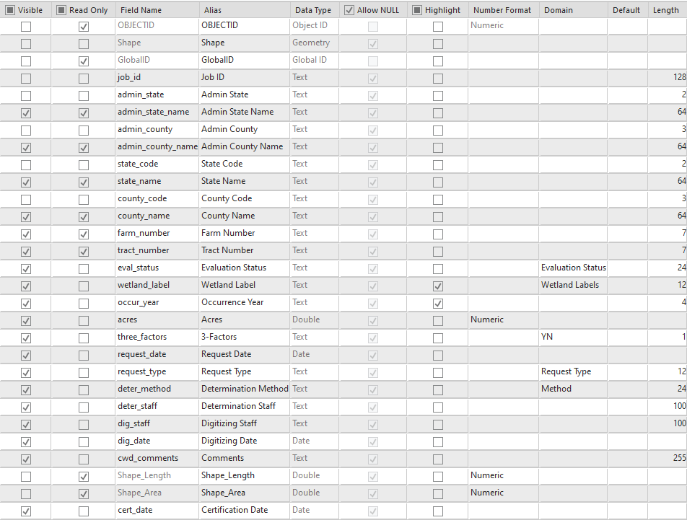

Figure 9 - CWD Feature Class Attribute Fields

* + 1. CLU Certified Wetland Determination (CLU CWD) Feature Class

The CLU CWD Feature Class is a polygon feature class that is used to delineate extents for wetland determinations and labels including FSA CLU field boundaries.

* + - 1. Workflow Components and Relationships

The CLU CWD Feature Class is created by intersecting the CWD feature class with the CLU feature class and automatically updating the attributes to incorporate fields and sub-fields. It is used on the final determination map and transferred to an archive layer when complete that aggregates all work. This feature class is added to the current project’s map as a layer.

* + - 1. Attributes

Most attributes in this feature class are inherited from the CWD feature class. CLU Number is re-introduced through geoprocessing. Acres are updated according to newly sub-divided delineations. The following additional attributes are specific to this layer:

1. *Name*: clu_number (Required)

*Alias*: CLU Number

*Data Type*: String/Text

*Length*: 7

*Value Description*: A 1- to 7-digit field number for each CLU field

*Default Value*: Spatially assigned from the source CLU layer.

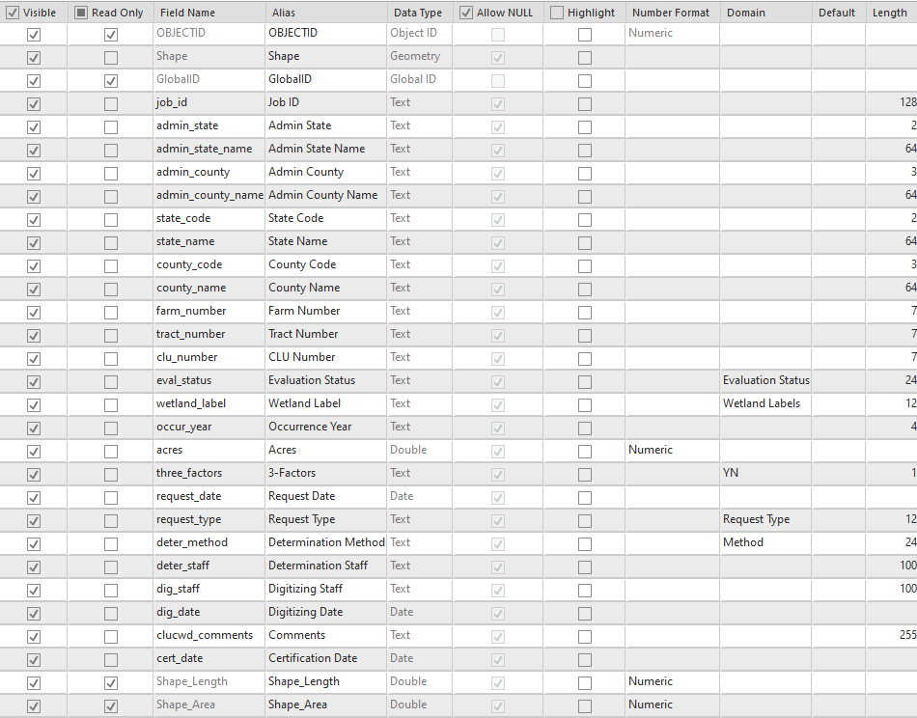

Figure 10 - CLU CWD Feature Class Attribute Fields

* 1. GIS States GeoPortal Data Model

This portion of the data model is for national Hosted Feature Services (HFS) to be stored on GIS States GeoPortal, which serve as data repositories for completed determination extents and labels. The layers interact with the wetland determination workflow by receiving uploaded data for newly completed determinations and by providing downloaded data to integrate alongside new requests. The following layers are all read/write and protected by Group managed permissions. All approved staff to work on wetland determinations are Group Members, and State Compliance and GIS Specialists are Group Managers. All layers will also have a corresponding read-only View for use in apps and dashboards. Hosted Feature Service Data layers are described in detail on the following pages.

* + 1. Request Extents HFS

This is a hosted feature layer that stores request extent polygons from completed determinations from the wetland determination tool digitizing workflow. It removes overlapping request extent polygons.

* + - 1. Workflow Components and Relationships

This layer is created by uploading and overwriting request extent polygons for completed determinations in a project’s active determination extent. Used in an operations dashboard to count digitized determinations.

* + - 1. Attributes

Same as the Request Extent feature class.

* + 1. All Request Extents HFS

This is a hosted feature layer that stores request extent polygons from all completed determinations from the wetland determination tool digitizing workflow, including overlapping extents if any revisions or recisions were made for any reason.

* + - 1. Workflow Components and Relationships

Uploaded from tool. Only duplicate Job IDs are protected seamlessly. Any other overlaps are allowed. Used in an operations dashboard to count digitized determinations.

* + - 1. Attributes

Same as the Request Extent feature class.

* + 1. Request Extent Points HFS

A centroid point representation of the Request Extents HFS for use in dashboards.

* + 1. All Request Extent Points HFS

A centroid point representation of the All Request Extents HFS for use in dashboards.

* + 1. Sampling Units HFS

This is a hosted feature layer that stores current sampling unit polygons from completed determinations from the wetland determination tool digitizing workflow. It removes overlapping sampling units.

* + - 1. Workflow Components and Relationships

This layer is created by uploading and overwriting sampling units for completed determinations in a project’s active determination extent. It is also used to import existing sampling units into new requests for alignment.

* + - 1. Attributes

Same as the Sampling Units Feature Class.

* + 1. All Sampling Units HFS

This is a hosted feature layer that stores sampling unit polygons from all completed determinations from the wetland determination tool digitizing workflow, including overlapping sampling units if any revisions were made for any reason.

* + - 1. Workflow Components and Relationships

Uploaded from tool. Only duplicate Job IDs are protected seamlessly. Any other overlaps are allowed.

* + - 1. Attributes

Same as the Sampling Units Feature Class.

* + 1. Representative Observation Points (ROPs) HFS

This is a hosted feature layer that stores current Representative Observation Points (ROPs) from completed determinations from the wetland determination tool digitizing workflow.

* + - 1. Workflow Components and Relationships

This layer is created by uploading ROPs for completed determinations in a project’s active determination extent. It is also used to import existing ROPs into new requests for reference.

* + - 1. Attributes

Same as the ROPs feature class.

* + 1. All Representative Observation Points (ROPs) HFS

This is a hosted feature layer that stores Representative Observation Points (ROPs) from all completed determinations from the wetland determination tool digitizing workflow, including previous ROPs if any revisions were made for any reason.

* + - 1. Workflow Components and Relationships

Uploaded from tool. Only duplicate Job IDs are protected seamlessly. All other ROPs are allowed.

* + - 1. Attributes

Same as the ROPs feature class.

* + 1. Reference Points HFS

This is a hosted feature layer that stores current Reference Points from completed determinations from the wetland determination tool digitizing workflow.

* + - 1. Workflow Components and Relationships

This layer is created by uploading Reference Points for completed determinations.

* + - 1. Attributes

Same as the Reference Points feature class.

* + 1. All Reference Points HFS

This is a hosted feature layer that stores Reference Points from all completed determinations from the wetland determination tool digitizing workflow, including previous Reference Points if any revisions were made for any reason.

* + - 1. Workflow Components and Relationships

Uploaded from tool. Only duplicate Job IDs are protected seamlessly. All other Reference Points are allowed.

* + - 1. Attributes

Same as the Reference Points feature class.

* + 1. Drainage Lines HFS

This is a hosted feature layer that stores current Drainage Lines from completed determinations from the wetland determination tool digitizing workflow.

* + - 1. Workflow Components and Relationships

This layer is created by uploading Drainage Lines for completed determinations.

* + - 1. Attributes

Same as the Drainage Lines feature class.

* + 1. All Drainage Lines HFS

This is a hosted feature layer that stores Drainage Lines from all completed determinations from the wetland determination tool digitizing workflow, including previous Drainage Lines if any revisions were made for any reason.

* + - 1. Workflow Components and Relationships

Uploaded from tool. Only duplicate Job IDs are protected seamlessly. All other Drainage Lines are allowed.

* + - 1. Attributes

Same as the Drainage Lines feature class.

* + 1. Certified Wetland Determinations (CWD) HFS

This is a hosted feature layer that stores current wetland determinations polygons from completed determinations from the wetland determination tool digitizing workflow. It removes overlapping wetland determination polygons.

* + - 1. Workflow Components and Relationships

This layer is created by uploading and overwriting wetland determination polygons for completed determinations in a project’s active determination extent. It is also used to import existing wetland determinations into new requests for alignment.

* + - 1. Attributes

Same as the Certified Wetland Determinations Feature Class.

* + 1. All Certified Wetland Determinations HFS

This is a hosted feature layer that stores wetland determination polygons from all

completed determinations from the wetland determination tool digitizing workflow, including overlapping determination polygons if any revisions or recisions were made for any reason.

* + - 1. Workflow Components and Relationships

Uploaded from tool. Only duplicate Job IDs are protected seamlessly. Any other overlaps are allowed.

2.2.4.2 Attributes

Same as the Certified Wetland Determinations feature class.

* + 1. Certified Wetland Determinations Points HFS

A centroid point representation of the Certified Wetland Determinations HFS for use in dashboards.

* + 1. All Certified Wetland Determinations Points HFS

A centroid point representation of the All Certified Wetland Determinations HFS for use in dashboards.

* + 1. CLU Certified Wetland Determinations (CLU CWD) HFS

This is a hosted feature layer that stores current wetland determinations polygons that are intersected with CLU data from completed determinations from the wetland determination tool digitizing workflow. It removes overlapping wetland determination polygons.

* + - 1. Workflow Components and Relationships

This layer is created by uploading and overwriting wetland determination polygons with CLU integrated data for completed determinations in a project’s active determination extent.

* + - 1. Attributes

Same as the CLU Certified Wetland Determinations feature class.

* + 1. All CLU Certified Wetland Determinations HFS

This is a hosted feature layer that stores wetland determination polygons that are intersected with CLU data from all completed determinations from the wetland determination tool digitizing workflow, including overlapping determination polygons if any revisions or recisions were made for any reason.

* + - 1. Workflow Components and Relationships

Uploaded from tool. Only duplicate Job IDs are protected seamlessly. Any other overlaps are allowed.

* + - 1. Attributes

Same as the Certified Wetland Determinations Feature Class.

* + 1. Potential Jurisdictional Waters (PJW) HFS

This is a hosted feature layer that stores current Potential Jurisdictional Waters (PJW) points from completed determinations from the wetland determination tool digitizing workflow.

* + - 1. Workflow Components and Relationships

This layer is created by uploading PJW points for completed determinations.

* + - 1. Attributes

Same as the PJW feature class.

* + 1. All Potential Jurisdictional Waters (PJW) HFS

This is a hosted feature layer that stores Potential Jurisdictional Waters (PJW) points from all completed determinations from the wetland determination tool digitizing workflow.

* + - 1. Workflow Components and Relationships

Uploaded from tool. Only duplicate Job IDs are protected seamlessly. All other PJW points are allowed.

* + - 1. Attributes

Same as the PJW feature class.

* 1. Data Model Domains

This section describes the attribute choice lists that will be configured for each feature class. Feature class descriptions might include one or more of the following domains.

* + 1. YN Domain

Y

N

* + 1. Yes-No Domain

Yes

No

* + 1. ROP Status Domain

Official

Reference

* + 1. Data Form Domain

Yes

No

Undetermined

* + 1. Line Type Domain

Drainage Ditch

Underground Tile

Manipulated Natural Water Course

Other

* + 1. Pre-Post Domain

Pre-1985

Post-1985

* + 1. Method Domain

Level 1 – Offsite

Level 2 – Onsite

Level 3 – Combination

Level 1 – SOSM

Level 3 – SOSM

* + 1. CWD Status Domain

Preliminary

Appealed

Final

* + 1. Request Type Domain

AD-1026  
FSA-569  
NRCS-CPA-38

* + 1. Evaluation Status Domain

New Request

Revision  
Certified-Digital

* + 1. Wetland Labels Domain

The content and order of the following list has been specified by agency leadership in charge of wetland conservation compliance as of 8/31/2020.

NW Non-Wetland

PC Prior-Converted Cropland

W Wetland

FW Farmed Wetland

FWP Farmed Wetland Pasture or Hayland

AW Artificial Wetland

WX Manipulated Wetland

MIW Mitigation Exemption

MW Minimal Effect Exemption

MWM Mitigation Site

TP Third Party Exemption

CW+ Converted Wetland plus year

CW Converted Wetland

CWIL Converted Wetland In-Lieu Fee

CWTA Converted Wetland Timely Assistance

CWTE Converted Wetland Technical Error

CPD Corps Permit Decision

PC/NW Prior-Converted Cropland/Non-Wetland

AW/FW Artificial Wetland/Farmed Wetland

AW/W Artificial Wetland/Wetland

NW/NAD Non-Wetland per National Appeals Division decision

CC Commenced Conversion

CWNA Converted Wetland for Non-Agricultural Purposes

NI Not Inventoried

* 1. Source Datasets

This is a list of data sources that may be consumed by the wetland determination tool.

* + 1. FSA CLU (from FSA Web Service)

https://gis.sc.egov.usda.gov/appserver/rest/services/common_land_units/common_land_units/FeatureServer/0

* + 1. NRCS Soil Survey (Soil Data Access)

https://SDMDataAccess.sc.egov.usda.gov/Spatial/SDMWGS84Geographic.wfs

* + 1. USGS NHD

https://gis.sc.egov.usda.gov/data/rest/services/hydrography/nhd/FeatureServer

* + 1. US FWS National Wetland Inventory (NWI)

https://gis.sc.egov.usda.gov/data/rest/services/wetlands/national_wetland_inventory/MapServer

* + 1. BLM PLSS Query Services

Town & Range: https://gis.blm.gov/arcgis/rest/services/Cadastral/BLM_Natl_PLSS_CadNSDI/MapServer/1/query

Sections:

https://gis.blm.gov/arcgis/rest/services/Cadastral/BLM_Natl_PLSS_CadNSDI/MapServer/2/query

* + 1. Best Available NAIP

https://gis.sc.egov.usda.gov/data/rest/services/ortho_imagery/naip/MapServer

* + 1. NRCS Elevation Services

1m DTM Service:

https://gis.sc.egov.usda.gov/image/services/elevation/1m_dtm/ImageServer

2m Service: https://gis.sc.egov.usda.gov/image/services/elevation/bare_earth_2m/ImageServer

3m Service:

https://gis.sc.egov.usda.gov/image/services/elevation/bare_earth_3m/ImageServer

5m Service:

https://gis.sc.egov.usda.gov/image/services/elevation/bare_earth_5m/ImageServer

* + 1. Local Datasets

Various. Managed by state coordinators.

* 1. Coordinate Systems
     1. GIS States GeoPortal Layers

*WGS84 Web Mercator Auxiliary Sphere (WMAS)*

* + 1. State/Local APRX Template Maps

State Coordinators/Administrators set a Coordinate System by selecting a WGS84-based UTM system during workflow and tool distribution setup.

* + 1. Determination Tool Workflow Datasets

Datasets generated by the Wetland Determination Tools workflow will utilize the Coordinate System from the *Determinations* map frame in the State/Local APRX Template. Based on item 2.5.2 above, and product documentation with release, this should be a WGS84-based UTM coordinate system.

* + 1. Local Reference Datasets

Varies.

* 1. Accuracy

The map products from this data model and the related wetland determination tool are representations, as is the case with all maps. All efforts are made to make maps as accurate as possible for the purposes of sharing information and communicating determination results. It should be noted that certified map delineations representing areas with assigned labels by this process are often not the official boundaries of an ineligible area. In many cases, the specific area of ineligibility will be determined by on site observation and delineation on the ground.

* + 1. Horizontal Accuracy

Horizontal accuracy for this standard is recommended to be similar to the NRCS conservation planning and the FSA CLU datasets as described in the 8-CM (Revision 1) Amendment 4 (USDA Farm Services Agency, 2012).

When the determination delineation source is hand drawn, on-screen (offsite) digitizing, the digitizing scale is recommended to be 1:4,800 or larger. Larger scales can be used where high-resolution aerial imagery is available.

When the determination delineation source is GPS, the maximum expected horizontal accuracy should not exceed 6.1 meters (20 feet). The actual expected horizontal accuracy, if the standard is adhered to, will be less than 3 meters under optimum conditions (USDA-NRCS, 2010).

* + 1. Accuracy Assessment

Accuracy assessment is a quantitative assessment (comparison of determinations conducted with methods and equipment capable of providing a higher level of accuracy) of boundary line positions and labeling, indicating the percentage of features that are in agreement.

**By National Policy, no specification for Accuracy Assessment is required in this standard.**

* 1. Topology Rules and Logical Consistency

Standard polygon topology rules are applied to the generation of data in the ArcGIS Pro Wetland Determination Tools and workflows. Overlaps and gaps from the source data layer (CLU) are not checked and corrected. Features that are generated by the workflow for upload to the hosted feature service will use their inherent feature extent to apply a topological update (erase and then append) into the “Current” hosted feature services, and all features that are unique (no matching Job IDs) will be appended to the “All” hosted feature services, where complete overlap will be allowed. The “All” hosted feature services are intended as a complete archive of all completed digitizing work that was ever uploaded from the ArcGIS Pro Wetland Determination Tools and workflows.

1. References

NRCS FSA, 2006:

*Final Report to Address Interagnecy Handling of Wetlands Conservation Compliance Documents Relating to the Use of ‘Blue Dots’*

USDA Farm Services Agency, 2012:

*Common Land Unit 8-CM (Rev. 1) Amend. 4. S.1*

USDA-NRCS, 2010:

*GPS Data Collection Standards for Conservation Planning, Technical, and Financial Assistance, s.1*

1. Participants

Denise Coleman

Dwain Daniels

Adolfo Diaz

Kevin Godsey

Paige Guetter

Gregg Hadish

Melissa Hanner

Jennifer Heglund

Kathy Irving

Joan Kinley-Howard

Darren Manthei

David Manthei

Chris Morse

Edwin Muniz

Jason Outlaw

Dee Pederson

Yuri Plowden

Ryan Ransom

Brent Stinson

Jeffrey Zimprich